SECC Night  Arizona united  vs.  State employee children in attendance will be part of the HIGH 5 Line to greet players before they head out to the pitch!  seattle sounders 2  The State Employee Charitable Campaign in partnership with Arizona United SC invites state employees with their families to a night of competition and fun between Arizona United and the Seattle Sounders 2!  When  June 20th  7:30 PM  Where  Scottsdale Stadium  7408 E Osborn Rd, Scottsdale, 85251  For purchasing information contact:  Linda Stiles at linda.stiles@azdoa.gov or call 602.542.0777  Jeff Penzone at jpenzone@arizonaunited.com or call 623.594.9606 e. 174 |  | 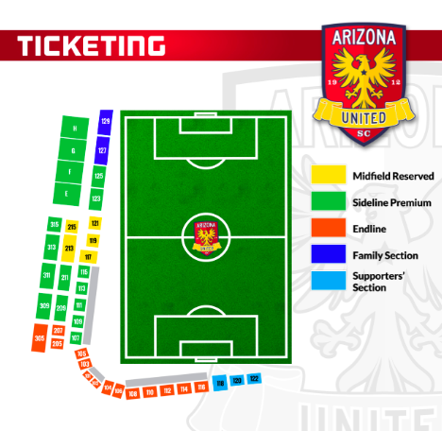 | 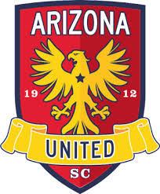  Ticket Price:  $18.00  Sections available at discount:  101, 102, 103, 105, 205, 207, 305  $22.00  Sections available at discount:  107, 109, 209, 211, 309, 311  Benefiting  A portion of each ticket sold goes directly to the State Employee Charitable Campaign for support in its mission to support and promote Arizona charities.

