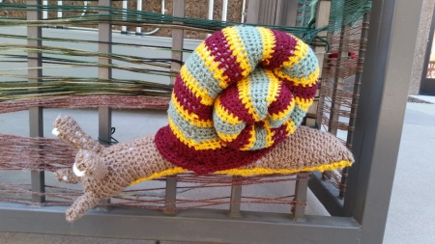 | Yarn Storming for Charity
If you are working at the Central Office building today you might have noticed the transformation the courtyard has gone through. The AHCCCS Fiber Artists and SECC have partnered to put up a yarn art installation for charity.

The purpose of the display is to raise awareness about Pancreatic Cancer. In 2011, it was estimated that there were 43,500 people living with pancreatic cancer in the United States. Pancreatic cancer rates have increased since that time. The estimated new cases for 2014 alone were over 46,000 and estimated deaths placed at almost 40,000. This yarn storming installation is in honor of Robert N. Hills, father of fellow employee, Katherine Hills, who passed away from pancreatic cancer.
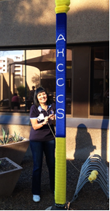
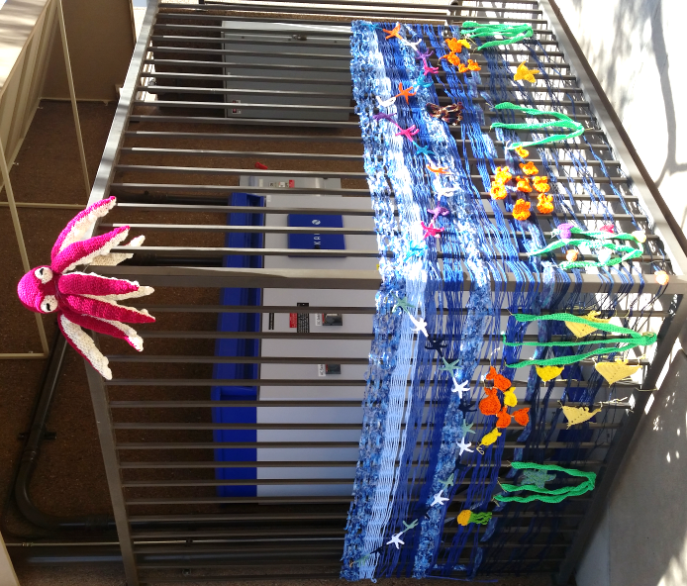
The proceeds from sponsorship of the display and donations we receive over the next week will benefit the Pancreatic Cancer Action Network. The Pancreatic Cancer Action Network is a nationwide network of people dedicated to working together to advance research, support patients and create hope for those affected by pancreatic cancer.

The knitted or crocheted items will be donated to Hospice of the Valley and the Ryan House. To learn more about each charity simply click on the links.

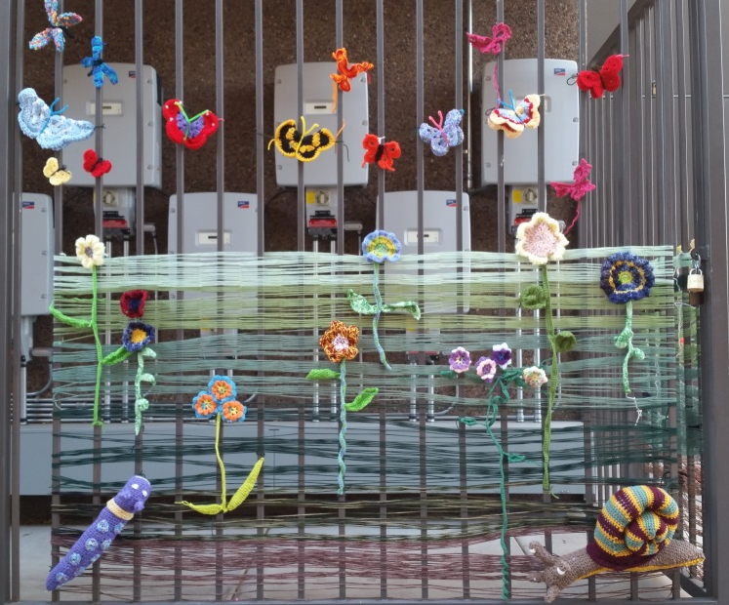
The artists and SECC members will be accepting donations. A representative will be in the Courtyard or Cafeteria between 11:30-1:00 every day through next Wednesday, June 25th. If you are a VO or Field Office worker you may send your donation to Megan Tormey. Please email her for the address.

These donations may be tax deductible. If you would like a receipt please let Megan know.

We would like to thank the artists and volunteers for their great work.

Our artists are: Katherine Hills, Gloria Díaz, Rebeca Haugse, Cherry Boardman, Erika Plante, Celia Renovato, Connie Williams, Julie Swenson, Tammy Retzlaff, Pat Nowak, Joanne Obenour, Gloria Gene, Dareth Cox, Kelly Gerard, and Penny Tougas.
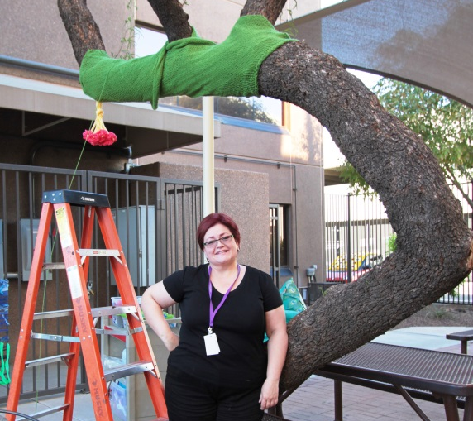
Thank you for all your support!

The Fiber Arts Club and SECC

